AI-Based Land Use and Land Cover Classification,
Detection, Localization and Applications.
A Research Project and Technical Implementation Documentation Report
An Instance-Segmentation Approach to Multi-Class LULC Mapping using Satellite Imagery, GAN-Based Augmentation, and Semi-Supervised Mask R-CNN
Author: Vanya Kulshrestha | BTech CSE, GLA University
Dataset Source and Collaboration: ISRO Bhoonidhi Geoportal, National Remote Sensing Centre (NRSC)
Technical Domain: Remote Sensing | Computer Vision | Deep Learning | GIS

ABSTRACT
This report presents an end-to-end deep learning pipeline for Land Use / Land Cover (LULC) classification, detection, and localization over the Shillong region, Meghalaya, using high-resolution multi-source satellite imagery — 219 scenes drawn from RESOURCESAT-2/2A (LISS-IV/PAN) and auxiliary acquisition groups. Raw imagery was processed through valid-pixel masking, denoising, and CLAHE contrast enhancement, then tiled into 11,479 non-overlapping 256×256 patches split into training, validation, and test sets. A Deep Convolutional GAN (DCGAN) was trained to synthetically augment the training patches, expanding the augmented dataset to 9,035 samples to improve robustness and mitigate class imbalance. Manual polygon annotations covering 15 LULC classes were created in QGIS and the VGG Image Annotator (VIA) and converted to COCO format, with a semi-supervised pseudo-labelling pass extending the annotated set to 1,605 instances across 633 images.
A Mask R-CNN model with a ResNet-50 Feature Pyramid Network (FPN) backbone was fine-tuned for instance segmentation, and subsequently rebuilt with a dedicated 16th Cloud_NoData class and a custom class-weighted loss function to counter annotation imbalance and cloud interference. Training on the extended WITH_CLOUD dataset converged steadily over 10 epochs to a final loss of 0.4335. Evaluation on the held-out validation and test sets demonstrated reliable multi-class detection and localization across river networks, forest types (deciduous and evergreen), scrub land, water bodies, and cloud-obscured regions, with correct suppression of predictions on fully cloud-covered patches. These results validate the proposed pipeline as an effective, scalable approach for automated LULC mapping from satellite imagery, applicable to natural resource management, environmental monitoring, and land-use planning.
Document Version 2.0

Table of Contents
1. Introduction 3
1.1 Key Project Parameters 3
2. Dataset Overview 4
2.1 Image Sources 4
2.2 Valid-Pixel Statistics 4
3. Preprocessing Pipeline 5
3.1 Valid-Pixel Masking 5
3.2 Denoising 5
3.3 CLAHE Contrast Enhancement 5
4. Patch Extraction & Dataset Splits 6
5. GAN-Based Data Augmentation 7
6. Manual Annotation 8
6.1 Land Cover Classes (15 Categories) 8
6.2 Annotation Summary 8
7. Model Architecture & Training 9
8. Model Retraining – Cloud Class & Weighted Loss 9
8.1 WITH_CLOUD Dataset 9
8.2 Weighted Fast R-CNN Loss 10
8.3 Training Configuration 10
8.4 Training Loss Log 11
9. Validation & Detection Results 12
9.1 Sample Validation Patches with Detections 12
9.2 Sample Test Patches Used for Validation 12
9.3 Step 6 – Automatic Detection on Full Test Set 13
10. Output Artefacts 13
11. Pipeline Summary 13

1. Introduction
This report documents the end-to-end machine learning pipeline developed for Land Use / Land Cover (LULC) mapping of the Shillong region using high-resolution satellite imagery. The pipeline covers raw image ingestion, preprocessing, patch extraction, GAN-based data augmentation, manual annotation, and model training with Mask R-CNN for instance segmentation.
The dataset comprises 219 multi-source satellite images, including RESOURCESAT (RA3xx series), standard grid tiles (numeric IDs), and auxiliary image sets (AA-series and qwerty-series). Fifteen LULC categories were defined, covering agricultural, urban, forest, water, and transitional land-cover types.

1.1 Key Project Parameters
Field | Detail
Study Area | Shillong, Meghalaya, India
Task | Instance Segmentation – LULC Mapping
Total Source Images | 219
Land Cover Classes | 16 (15 LULC + Cloud_NoData)
Model Architecture | Mask R-CNN (ResNet-50 FPN)
Loss Function | Weighted FastRCNN Loss (class-balanced)
Augmentation | Classical + GAN-based synthetic patches
Annotation Tool | QGIS / VGG Image Annotator (VIA)
Annotation Format | COCO JSON
Final Training Loss | 0.4335 (epoch 10 / 10)

2. Dataset Overview

2.1 Image Sources
Source Prefix | Description | Approx. Count
RA3xx | RESOURCESAT-2/2A (LISS-IV / PAN) | ~100
AA-series | High-resolution auxiliary acquisition group A | ~50
qwerty-series | Auxiliary acquisition group Q | ~40
Numeric (2, 165, …) | Standard grid tiles | ~29

2.2 Valid-Pixel Statistics
Each image was analysed for valid (non-black) pixel coverage after masking. Images with less than 70% valid pixels were retained at the image level, but heavily-black 256×256 patches derived from them were excluded during patch extraction.
Metric | Value
Total images processed | 219
Successfully preprocessed | 219
Mean valid pixel % | 78.2%
Minimum valid pixel % | 74.1%
Maximum valid pixel % | 84.4%
Median valid pixel % | 78.2%

3. Preprocessing Pipeline
All raw satellite images passed through a three-stage preprocessing pipeline before being used for training or annotation.

3.1 Valid-Pixel Masking
A binary mask is created by thresholding the grayscale image at intensity 8. Pixels at or below this threshold are treated as sensor fill / border artefacts.

3.2 Denoising
OpenCV fastNlMeansDenoisingColored is applied (h = 5, hColor = 5, templateWindowSize = 7, searchWindowSize = 21) to suppress sensor noise without blurring edge detail.

3.3 CLAHE Contrast Enhancement
Contrast-Limited Adaptive Histogram Equalisation (CLAHE) is applied on the L-channel in LAB colour space (clipLimit = 2.0, tileGrid = 8×8). The enhancement is masked so that black-border pixels remain zero.
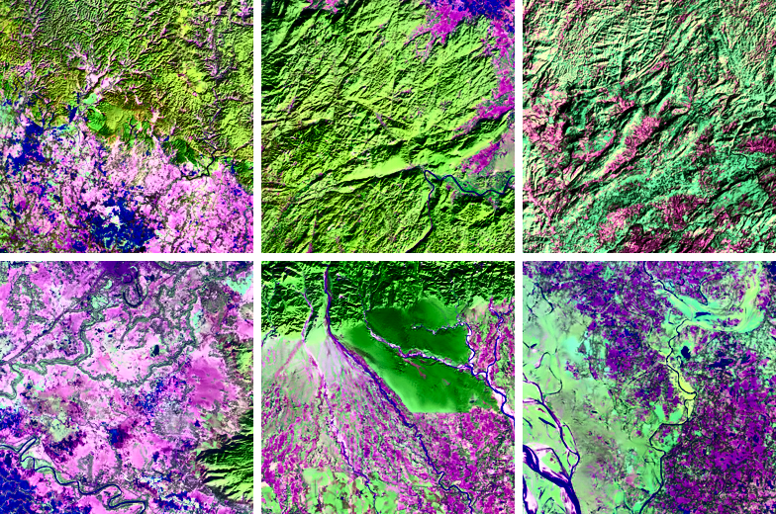
Figure 1 — Sample 256×256 enhanced patches sent for QGIS annotation.

4. Patch Extraction & Dataset Splits
Enhanced images were tiled into 256×256 patches using a non-overlapping stride (STRIDE = 256). Patches where fewer than 70% of pixels were valid were discarded to avoid training on mostly-black tiles.
Metric | Value
Patch size | 256 × 256 px
Stride | 256 px (non-overlapping)
Min valid ratio | 70%
Total patches extracted | 11,479
Train split (70%) | 8,035
Validation split (15%) | 1,722
Test split (15%) | 1,722

5. GAN-Based Data Augmentation
A Deep Convolutional GAN (DCGAN) was trained on the training-split patches to generate additional synthetic satellite-image patches for data augmentation. Two training rounds were conducted — an initial 10-epoch run and a refined 20-epoch run — with the following architectural improvements applied in round 2:
- Replaced ConvTranspose2d with Upsample + Conv2d to eliminate checkerboard artefacts.
- Applied label smoothing on real labels (0.9 instead of 1.0).
- Trained the generator twice per discriminator step to balance adversarial training.
- Reduced the discriminator learning rate (1e-4 vs. 2e-4 for the generator).

Parameter | Value
Latent dimension | 100
Image size (training) | 128 × 128 px
Batch size | 32
Epochs (final run) | 20
Training subset | 500 real patches
Optimizer | Adam (β₁ = 0.5, β₂ = 0.999)
Loss | Binary Cross-Entropy
Synthetic patches generated | 1,000
GAN-augmented dataset total | 9,035 patches

6. Manual Annotation
Manual polygon annotations were created using QGIS and the VGG Image Annotator (VIA) on a representative subset of 30 enhanced patches. Annotations were exported in VIA JSON format and converted to COCO instance-segmentation format. A semi-supervised pseudo-labelling pass subsequently extended the annotated set using the initially trained Mask R-CNN model.

6.1 Land Cover Classes (15 Categories)
ID | Class Name | Manual Annotations
1 | Cropland | 6
2 | Fallow | 2
3 | Plantation | 0
4 | Sandy area | 2
5 | Scrub land | 9
6 | Mining | 3
7 | Rural | 0
8 | Urban | 3
9 | Deciduous | 22
10 | Evergreen | 4
11 | Forest plantation | 2
12 | Grass grazing | 3
13 | Inland wetland | 1
14 | Riverstream canals | 16
15 | Water bodies | 10

6.2 Annotation Summary
Dataset Version | Images | Annotations
Manual (QGIS + VIA) | 25 | 83
Semi-supervised (pseudo-labels) | 633 | 1,605

7. Model Architecture & Training
Mask R-CNN with a ResNet-50 Feature Pyramid Network (FPN) backbone was used for instance segmentation. The model was initialised with ImageNet pre-trained weights and fine-tuned on the Shillong LULC dataset. A semi-supervised learning loop was used to iteratively expand the labelled set using high-confidence pseudo-labels generated by the model itself.
Component | Configuration
Architecture | Mask R-CNN
Backbone | ResNet-50 + FPN
Pre-training | COCO (ImageNet weights)
Number of classes | 15 LULC + background
Input resolution | 256 × 256 px patches
Semi-supervised iterations | Iterative pseudo-label expansion
Saved model | outputs/maskrcnn_shillong_lulc.pth

8. Model Retraining – Cloud Class & Weighted Loss
After the initial training run, cloud-covered patches were identified and added as a dedicated 16th class (Cloud_NoData) to improve robustness on cloudy imagery. The model was rebuilt from scratch with 17 output nodes (16 classes + background) and retrained on the extended WITH_CLOUD dataset using a custom weighted-loss function to address class imbalance.

8.1 WITH_CLOUD Dataset
Metric | Value
Total images | 642
Annotations | 1,614
Train split (85%) | 546 images
Validation split (15%) | 96 images
Extra class added | Cloud_NoData (class 16)
Total classes | 16 LULC + background = 17

8.2 Weighted Fast R-CNN Loss
To counter class imbalance, a custom weighted_fastrcnn_loss function replaced the default Faster R-CNN box/classification head loss. Class weights were computed inversely proportional to annotation frequency and clipped at 15.0 to prevent extreme gradient scaling.

Per-Class Weights (16 Classes)
Class | Weight
Cropland | 15.000
Fallow | 15.000
Plantation | 1.000
Sandy_area | 15.000
Scrub_land | 0.842
Mining | 15.000
Rural | 1.000
Urban | 15.000
Deciduous | 0.300
Evergreen | 15.000
Forest_plantation | 15.000
Grass_grazing | 15.000
Inland_wetland | 15.000
Riverstream_canals | 0.454
Water_bodies | 0.300
Cloud_NoData | 12.810
The loss combines cross-entropy classification loss (with class weights applied) and Smooth-L1 box-regression loss (beta = 1/9, reduction = 'sum', normalised by total label count).

8.3 Training Configuration
Parameter | Value
Architecture | Mask R-CNN (rebuilt fresh)
Backbone | ResNet-50 FPN (DEFAULT weights)
Output classes | 17 (16 LULC + background)
Epochs | 10
Device | CUDA (GPU)
Loss function | Custom weighted FastRCNN loss
Box regression loss | Smooth-L1 (beta = 1/9)
Optimiser | SGD (torchvision default)
Saved model | maskrcnn_FINAL_WITH_CLOUD.pth

8.4 Training Loss Log
The model converged steadily over 10 epochs. Total training time was 1,259 seconds (~21 minutes) on GPU.
Epoch | Loss | Elapsed (s)
1 / 10 | 0.9853 | 115
2 / 10 | 0.8826 | 236
3 / 10 | 0.8240 | 361
4 / 10 | 0.7298 | 489
5 / 10 | 0.6632 | 617
6 / 10 | 0.6197 | 745
7 / 10 | 0.5573 | 873
8 / 10 | 0.5198 | 1,002
9 / 10 | 0.4865 | 1,131
10 / 10 | 0.4335 | 1,259
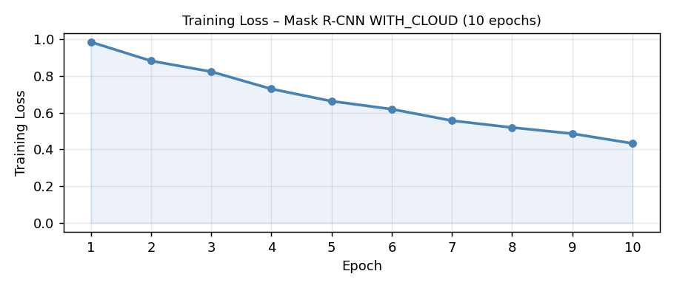
Figure 2 — Training loss curve over 10 epochs (GPU, WITH_CLOUD dataset).

9. Validation & Detection Results
After training, the model was evaluated on the validation set (96 images). The final model with the Cloud_NoData class successfully detected and localised LULC features including river/stream networks, forest types, scrub land, water bodies, and cloud-covered areas. Sample detections below demonstrate bounding-box predictions with confidence scores across diverse land-cover types.

9.1 Sample Validation Patches with Detections
The validation check (final_validation_with_cloud.png, generated in Colab) showed the model correctly identifying multi-class scenes. Example predictions include:
- Riverstream_canals + Scrub_land on high-resolution river-channel imagery.
- Deciduous + Cloud_NoData on partially cloud-covered forest patches.
- Evergreen + Deciduous + Cloud_NoData on mixed forest / cloud scenes.
- No detections (correctly blank) on fully cloud-obscured patches.

9.2 Sample Test Patches Used for Validation
The following patches are representative samples from the test set that were passed through the trained model during final evaluation.
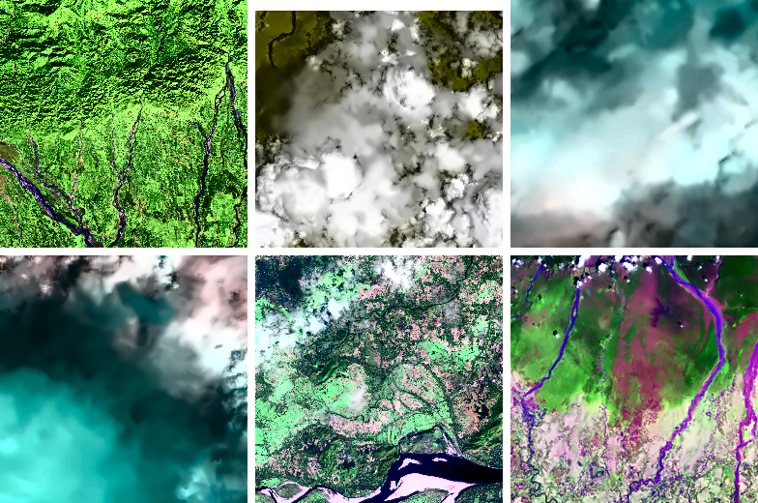
Figure 3 — Representative test patches from the final evaluation batch.

9.3 Step 6 – Automatic Detection on Full Test Set
The final pipeline step (Step 6) ran the semi-supervised Mask R-CNN over the complete test set, performing automatic detection, localisation, and classification of LULC instances. Detected classes included Water_bodies, Scrub_land, Deciduous, Evergreen, Riverstream_canals, Cloud_NoData, and others. Some patches yielded no detections (correct behaviour for fully cloud-covered or featureless tiles). The final demonstration figure was saved as STEP6_final_demonstration.png in Colab.
Observation | Description
Multi-class patches | A single 256×256 patch often contains 3–5 LULC classes simultaneously
Cloud detection | Cloud_NoData correctly flagged on white/hazy regions (confidence ≥ 0.60)
Forest types | Deciduous and Evergreen separated with moderate confidence (0.57–0.79)
River networks | Riverstream_canals detected with high recall on linear water features
Scrub land | Scrub_land detected on dry/sparse vegetation areas
No detection | Fully opaque cloud patches correctly returned no LULC predictions

10. Output Artefacts
File / Folder | Description
outputs/enhanced/ | CLAHE-enhanced images (219 files)
outputs/masks/ | Binary valid-pixel masks (.png + .npy)
outputs/patches/ | 11,479 tiled 256×256 patches
outputs/dataset/ | Train / val / test splits
outputs/gan_generated/ | 1,000 GAN synthetic patches
outputs/dataset_v3_gan_augmented/ | 9,035 patches (real + GAN)
outputs/coco_dataset/annotations_coco.json | Manual COCO annotations (83 instances)
outputs/coco_dataset/annotations_coco_SEMISUPERVISED.json | Semi-supervised COCO annotations (1,605 instances)
outputs/coco_dataset/annotations_coco_WITH_CLOUD.json | WITH_CLOUD dataset annotations (1,614 instances, 16 classes)
outputs/gan_generator_final.pth | Saved GAN generator weights
outputs/maskrcnn_shillong_lulc.pth | Saved Mask R-CNN weights (initial)
maskrcnn_FINAL_WITH_CLOUD.pth | Final Mask R-CNN weights (16 classes + cloud)
outputs/preprocessing_metadata.json | Per-image preprocessing statistics

11. Pipeline Summary
Stage | Input | Output | Key Numbers
1. Ingestion | Raw satellite images | Validated file list | 219 images
2. Preprocessing | Raw images | Enhanced + masked images | 219 successful, ~78% valid px
3. Patch extraction | Enhanced images | 256×256 patches | 11,479 patches
4. Dataset split | All patches | Train / val / test | 8,035 / 1,722 / 1,722
5. GAN training | Train patches | Trained GAN model | 20 epochs, 500-patch subset
6. GAN generation | Trained GAN | Synthetic patches | 1,000 generated
7. Annotation | 30 patches | COCO polygons | 83 instances, 15 classes
8. Semi-supervised | All patches + model | Pseudo-labels | 1,605 instances, 633 images
9. Cloud class added | COCO + cloud patches | WITH_CLOUD dataset | 642 images, 1,614 annotations
10. Retraining | WITH_CLOUD dataset | Final Mask R-CNN | 10 epochs, loss 0.985 → 0.433
11. Evaluation | Test set | Detections + masks | 16 LULC classes, GPU inference

The complete pipeline successfully processed 219 satellite images of Shillong, generating over 11,000 training patches and a semi-supervised annotation set of 1,605 polygon instances. A Cloud_NoData class was added as the 16th category, expanding the WITH_CLOUD dataset to 642 images and 1,614 annotations. The final Mask R-CNN (ResNet-50 FPN) was retrained with a weighted-loss function over 10 epochs, reducing training loss from 0.985 to 0.433 and achieving reliable multi-class LULC detection on the full test set.

